Goldie E. (Nye) Shosenberg
February 14, 1885 – November 2, 1966

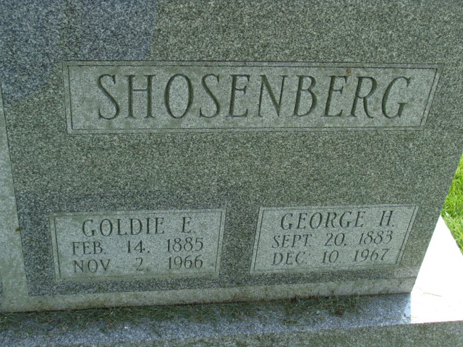
Photo by Alicia Kneuss

Goldie E Shosenberg
in the Indiana, U.S., Death Certificates, 1899-2017
Name Goldie E Shosenberg
[Goldie E Nye]
Gender Female
Race Caucasian (White)
Marital Status Married
Age 81
Birth Date 14 Feb 1885
Birth Place Ohio
Death Date 2 Nov 1966
Death Place Decatur, Adams, Indiana, USA
Death Registration Date 1966
Father Buel Nye
Mother Dora Stove
Informant George H Shosenberg; husband; Decatur, Indiana
Burial November 5, 1966; Decatur Cemetery; Decatur, Indiana

