George H. Shosenberg
September 20, 1883 – December 10, 1967

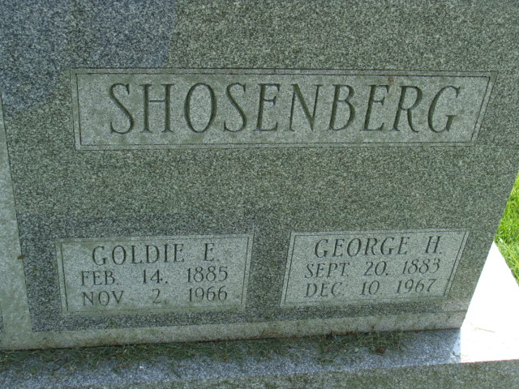
Photo by Alicia Kneuss

George H Shosenberg
in the Indiana, U.S., Death Certificates, 1899-2017
Name George H Shosenberg
Gender Male
Race White
Marital Status Widowed
Age 84
Birth Date 20 Sep 1883
Birth Place Ohio
Death Date 10 Dec 1967
Death Place Fort Wayne, Allen, Indiana, USA
Death Registration Date 1967
Father John Shosenberg
Mother Dora Hunt
Informant Mrs. James M. Burk; daughter; Decatur, Indiana
Burial December 13, 1967; Decatur Cemetery; Decatur, Indiana

