Francis B. Shores
May 17, 1883 – October 14, 1955

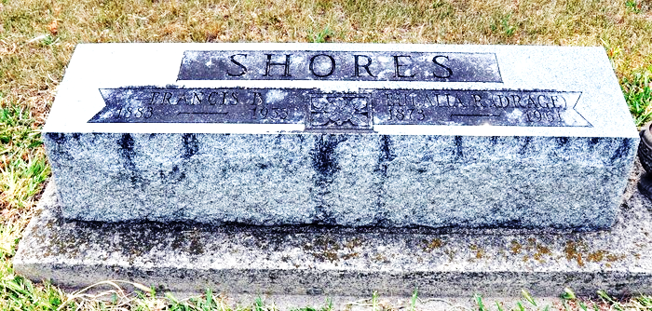
Photo by Deb Curry

Francis B Shores
in the Indiana, U.S., Death Certificates, 1899-2017
Name Francis B Shores
Gender Male
Race White
Marital Status Married
Age 72
Birth Date 17 May 1883
Birth Place Oklahoma
Death Date 14 Oct 1955
Death Place Fort Wayne, Allen, Indiana, USA
Death Registration Date 1955
Father John Shores
Mother Nancy Crandall
Informant Mrs. Shores; wife
Burial October 17, 1955; Oak Lawn Cemetery [sic]; Ossian, Indiana

