Eulalia (Archbold) Shores
May 24, 1873 – April 27, 1961

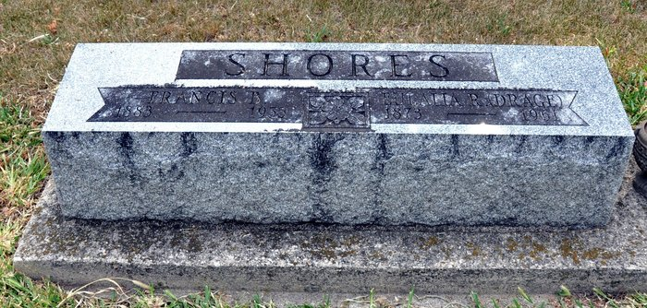
Photo by Deb Curry

Eulalla Shores
in the Indiana, U.S., Death Certificates, 1899-2017

Name Eulalia Shores
[Eulalia Archbold]
Gender Female
Race Caucasian (White)
Marital Status Widowed
Age 87
Birth Date 24 May 1873
Birth Place Ossian, Indiana
Death Date 27 Apr 1961
Death Place Columbia, Whitley, Indiana, USA
Death Registration Date 1961
Father John Archbold
Mother Rose Glock
Informant Harold Dreg [sic]; son; Ossian, Indiana
Burial April 29 1961; Maple Grove Cemetery; Decatur, Indiana

