Xariffa Cora (Brodbeck) Shook
October 31, 1900 – May 25, 1960

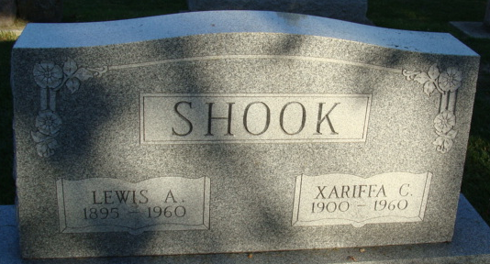
Photo by Alicia Kneuss

Ohio, County Death Records, 1840-2001

Name Cora Xariffa Shook
Sex Female
Age 59y
Occupation Housewife
Race White
Father's Name Harvey E Brodbeck
Mother's Name Iva M Thomas
Event Type Death
Event Date 25 May 1960
Event Place Wren, Willshire Township, Van Wert, Ohio, United States
Event Place (Original) Wren, Van Wert, Ohio
Cemetery Decatur Cemetery
Residence Place Wren, Ohio
Birth Date 31 Oct 1900
Birthplace Indiana
Burial Date 28 May 1960
Burial Place Decatur, Indiana
Informant Mrs. Waldo Eckrote; Decatur, Indiana
**
Will of Zariffa Shook
Name in Record; Reason for Being in Record; Date of Record
Zariffa Shook; Makes her last will & testament; May 17, 1960
UB in Christ Church, Wren, Ohio; To receive 500.00 for upkeep & maintenance
Fannie Whittung; Of Rockford, Ohio; to share first 1/2 of estate
Blanche Welker; Of Decatur, Indiana; to share first 1/2 of estate
Lawrence Shook; Of Sturgis, Michigan; to share first 1/2 of estate
John Shook; Of Decatur, Indiana; to share first 1/2 of estate
Theodore Shook; Of Convoy, Ohio; to share first 1/2 of estate
Rufford Brodbeck; Brother; to share second 1/2 of estate
Gertrude Martin; Sister; to share second 1/2 of estate
Ruth Eckrote; Sister; to share second 1/2 of estate
Gerald Brodbeck; Brother; to share second 1/2 of estate
Marcus Brodbeck; Appointed executor of will of Zariffa Shook
John L. Devoss; Of Decatur, Indiana; witnessed Zariffa Shook making her last will
Marie Debolt; Of Decatur, Indiana; witnessed Zariffa Shook making her last will
Zariffa Shook; Died May 25, 1960
Marcus Brodbeck; Oath of death; May 31, 1960
John L. Devoss; Subscribing witness; oath of validity of will; May 31, 1960
Richard D. Lewton Clerk; will has been admitted to probate; May 31, 1960

