Lewis Allen Shook
May 3, 1895 – April 2, 1960

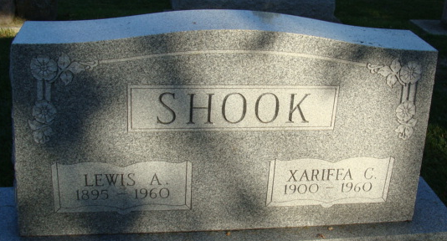
Photo by Alicia Kneuss

Lewis Allen Shook
in the Ohio, U.S., Births and Christenings Index, 1774-1973
Name Lewis Allen Shook
Gender Male
Race White
Birth Date 3 May 1895
Birth Place Willshire Township, Van Wert, Ohio
Father Benjamin John Shook
Mother Sadie Myers
FHL Film Number 1015857
**

Indiana, U.S., Death Certificates, 1899-2017
Name Lewis A Shook
Gender Male
Race White
Marital Status Married
Age 64
Birth Date 3 May 1895
Birth Place Ohio
Death Date 2 Apr 1960
Death Place Decatur, Adams, Indiana, USA
Death Registration Date 1960
Father Benjamin Shook
Mother Sadie Myers
Informant Mrs. Xariffa Shook; wife; Wren, Ohio
Burial April 5, 1960; Decatur Cemetery; Decatur, Indiana

