Leona A. (Welker) Shook
June 4, 1902 – November 13, 1983

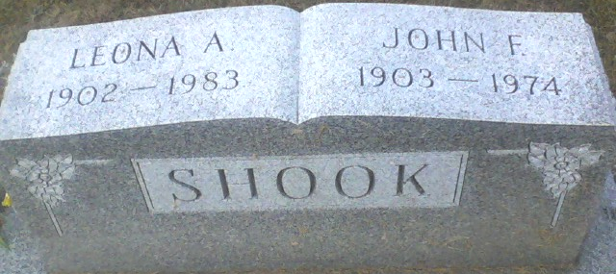
Photo by Alicia Kneuss

Leona A. Shook, 81, 116 East Grant St., who retired from the Adams County Memorial Hospital in 1964 after 18 years of service, died at 10:50 p.m. Sunday at the hospital, where she had been a patient eight days. She had been in failing health two years.
She attended the Decatur United Brethren Church.
Born in Adams County on June 4, 1902 , she was the daughter of S. T. and Sarah Catherine Chronister-Welker, and was married Dec. 23, 1920, to John F. Shook; he died April 27, 1974.
Survivors include a son, Bill Shook, Decatur; two sisters, Mrs. May Tope, Decatur, and Mrs. Vernon (Ethel) Bowman, Van Wert, O.; a brother, Matthias Welker, Decatur; four granddaughters and six great-grandchildren. One daughter, Betty Davidson; a son, Ermel Shook, and five brothers and one sister preceded her in death.
Services will be held Wednesday at 1:30 p.m. at the Zwick-Boltz & Jahn Funeral Home, with Rev. Reuben Zurcher officiating. Burial will be in the Decatur Cemetery. Friends may call at the funeral home after 2 p.m. Tuesday.
Memorials are to the church.

Decatur Daily Democrat, Adams County, Indiana
November 14, 1983

