John F. Shook
September 22, 1903 – April 27, 1974

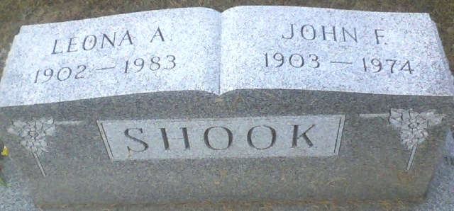
Photo of Alicia Kneuss

John F. Shook Funeral Today
Funeral services for John F. Shook, 70, of 116 Grand Street, will be held at 3:30 p.m. today at the Zwick Funeral Home, the Rev. Sylvester Martin officiating. Burial will be in the Decatur Cemetery. Shook was taken to the Adams County Memorial Hospital at 5 p.m. Saturday, where he was pronounced dead on arrival.
A native of Wren, O., he was born Sept. 22, 1903, the son of Benjamin and Sarah Myers-Shook. He was married Dec. 23, 1920 to Leona Welker, who survives.
A former employee of the Mutschler Packing Co., and Decatur General Electric plant, he had been employed at the Adams County Memorial Hospital for the past 12 years. He was a member of the father’s auxiliary of the Decatur V.F.W.
Survivors include a son, Bill Shook of Decatur, and a daughter Mrs. L.L. (Betty) Davidson, of Decatur; four grandchildren and four great-grandchildren; and a brother, Theodore Shook of Convoy, O. Five sisters and three brothers are deceased.

Decatur Daily Democrat, Adams County, Indiana
Monday, April 29, 1974

