Helen L. (McDorman) Shook
May 9, 1930 – December 26, 2003

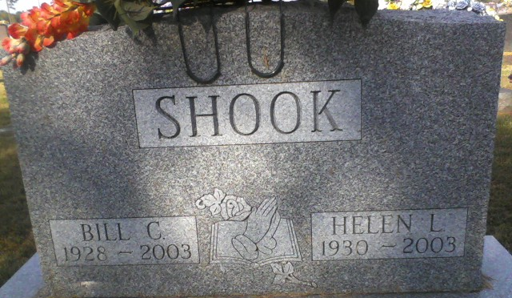
Photo by Alicia Kneuss

Helen L. Shook, 73, of Fort Wayne, formerly a longtime resident of Decatur, died Friday, Dec. 26, 2003, at Hospice Home of Northeast Indiana. She was born May 9, 1930, in Van Wert County, Ohio, the daughter of John F. Cecil (Denney) McDorman. She married Billy C. Shook on August 2, 1952, in Bluffton.
She was a homemaker and attended Decatur United Brethren Church.
Surviving are her daughters, Mrs. James (Debra A.) Grider and Mrs. Frank (Sandra) Shoener, both of Fort Wayne; brother, Roy L. McDorman of Mendon, Ohio; sisters, Ethel V. Jamieson of Van Wert Ohio and V. Ione Byer of Glenmore, Ohio; and four grandchildren. She was preceded in death by her parents, husband, on Aug. 28, 2003; two brothers, Earl and Dale McDorman; and one sister, Clarissa May McDorman.
Service is 3 p.m. Monday at Zwick & Jahn Funeral Home, Decatur, with the Rev. James Sturgeon officiating. Visitation is from 1 to 3 p. m. Monday before the service at the funeral home. Burial at Decatur Cemetery.
Memorials to Decatur United Brethren Church or donor's choice.

News-Sentinel, Allen County, Indiana
Sunday, December 28, 2003

