Ermel E. Shook
November 25, 1921 – July 4, 1950

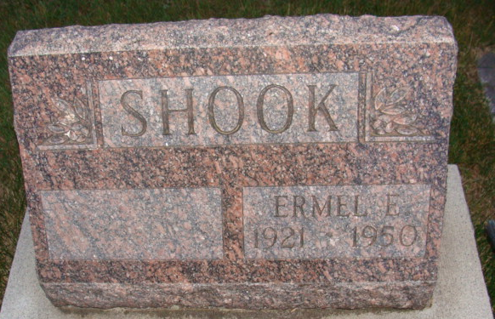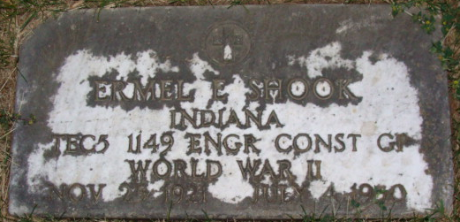
Photo by Alicia Kneuss

Ermel E Shook
in the Indiana, U.S., Death Certificates, 1899-2017
Name Ermel E Shook
Gender Male
Race White
Marital Status Married
Age 28
Birth Date 25 Nov 1921
Birth Place Wren Ohio
Death Date 4 Jul 1950; accidental drowning
Death Place Noble, Indiana, USA
Father John Shook
Mother Unknown
Informant Marjorie Shook
Burial July 7, 1950; Maplewood Cemetery; Decatur, Indiana
**
Indiana, U.S., Marriage Certificates, 1960-2012
Name Ermel Shook
Gender Male
Race White
Marriage Age 21
Birth Date 4 May 1921
Birth Place Ohio
Marriage License Date 16 May 1942
Marriage Date 23 May 1942
Marriage Place Adams, Indiana, USA
Residence Place Lima, Ohio
Father John Shook
Mother Leona Walker
Spouse Marjorie E Butler
Other Person Clyde O Troutner
Officiator W L Hall

