Bill C. Shook
April 12, 1928 – August 28, 2003

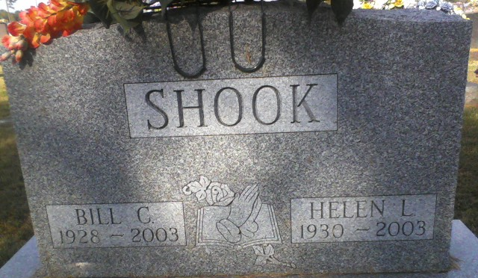
Photo by Alicia Kneuss

Bill C Shook
in the Indiana, U.S., Death Certificates, 1899-2017
Name Bill C Shook
Gender Male
Race White
Marital Status Married
Age 75
Birth Date 12 Apr 1928
Birth Place Wren, Ohio
Death Date 28 Aug 2003
Death Place Fort Wayne, Allen, Indiana, USA
Death Registration Date 2003
Father John F Shook
Mother Leona A Welker
Spouse Helen McDorman
Informant Helen Shook; wife; Columbia City, Indiana
Burial August 30, 2003; Decatur Cemetery; Decatur, Indiana

