Nellie (Vincent) Sholty
September 27, 1856 – December 9, 1930

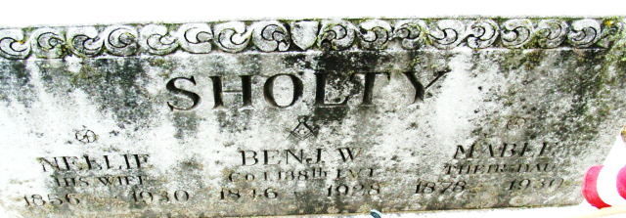
Photo by Alicia Kneuss

Mrs Nellie Sholty
in the Indiana, U.S., Death Certificates, 1899-2017
Name Mrs Nellie Sholty
[Mrs Nellie Vincent]
Gender Female
Race White
Marital Status Widow
Age 74
Birth Date 27 Sep 1856
Birth Place Point Pleasant, W. Virginia
Death Date 9 Dec 1930
Death Place Decatur, Adams, Indiana, USA
Death Registration Date 1930
Father Chas. Vincent
Mother Martha Ward
Informant Mrs. W. F. Gazette; Little Rock, Arkansas
Burial December 12, 1930; Decatur

