Edna Mable Sholty
August 27, 1878 – January 13, 1930

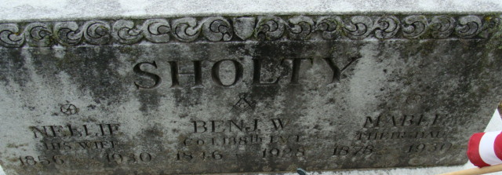
Photo by Alicia Kneuss

Edna Mafle Shalty
in the Indiana, U.S., Death Certificates, 1899-2017
Name Edna Mable Sholty
Gender Female
Race White
Marital Status Single
Age 57
Birth Date 27 Aug 1877
Birth Place Indiana
Death Date 13 Jan 1930
Death Place Decatur, Adams, Indiana, USA
Death Registration Date 1930
Father Bengiman Sholty
Mother Nellie Vincent
Informant Nellie Sholty
Burial January 15, 1930; Decatur Cemetery

