Benjamin Wesley Sholty
March 12, 1846 – September 8, 1928

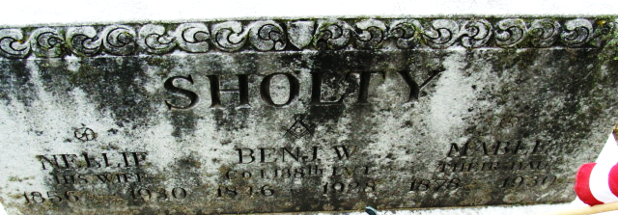
Photo by Alicia Kneuss

Benigerian Wisley Shally
in the Indiana, U.S., Death Certificates, 1899-2017
Name Bengaman Wesley Sholty
Gender Male
Race White
Marital Status Married
Age 82
Birth Date 12 Mar 1846
Birth Place Ohio
Death Date 8 Sep 1928
Death Place Decatur, Adams, Indiana, USA
Death Registration Date 1928
Father Henry Sholty
Mother Susan Weimer
Spouse Nellie
Informant Nellie Sholty
Burial September 10, 1928; Decatur Cemetery

**
Benjamin Wesley Sholty from Tegerdine/Morden/Crawford Family Tree
Spouse Nellie Vincent
Father Henry John Sholty
Mother Susanna Weimer
Children Edna Mabel
Birth 12 Mar 1846 Stark, Ohio, USA
Death 8 Sep 1928 Decatur, Adams, Indiana, USA
Residence 1870 Roanoke, Huntington, Indiana, USA

