Lewis M. Shoe
September 11, 1920 - March 14, 1946

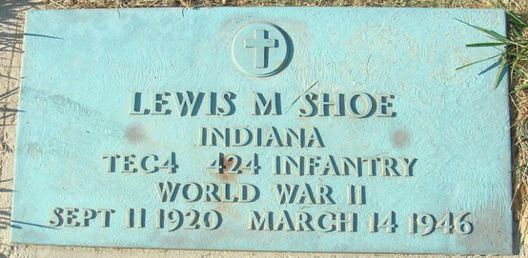
Photo by Alicia Kneuss

DECATUR MAN, WOMAN VICTIMS DIE INSTANTLY
EAST BOUND PENNSY TRAIN HITS AUTO ON MAIN STREET CROSSING NEAR 11 P.M.

The lives of two residents of Decatur, Ind, were snuffed out Thursday night when their automobile was struck by an east-bound Pennsylvania passenger train on the Main Street crossing in Convoy, OH. The accident brought the county's railroad crossing fatality toll to six in the past five days.
The dead are: Lewis M. Shoe, 25, garage mechanic, reported to have been the driver of the automobile, and Dorothy Ella Bassett, 37, said to be the mother of several children. Both of the victims were killed instantly.
Sheriff F. Roy Shaffer, assisted by Deputy Sheriff Harry Henry, said the accident occurred at 10:05 p.m. when the south-bound Decatur auto drove onto the crossing directly in the path of the east-bound train NO. 42.
BODIES HURLED FROM CAR
The wreckage of the demolished car, an old model light coach, was scattered along the tracks about 150 feet from the crossing. The bodies were hurled from the car and both were mutilated beyond recognition. Identity of the bodies was established by the officers through papers found in their clothing.
The bodies were removed to the Hertz Funeral Home in Convoy and later were taken to the Zwick Funeral Home at Decatur. Dr. E.H. Alspaugh, county coroner, has returned a finding of accidental death.
Sheriff Shaffer said that he learned the couple had left a cafe in Convoy shortly before the accident, and it was believed they were en route home, taking State Highway No. 49, which is Main Street through the town. The crossing is said to be protected by gates until 10 p.m.
FORMER DELPHOS RESIDENT
The crossing is approximately one and one-half miles west of the Holmes or Lincoln Highway crossing where four prominent Van Wert residents were killed in last Sunday night's tragedy.
Mrs. Bassett, the wife of Carroll Bassett, an employee of the International Harvester Company in Fort Wayne, was born on January 4, 1909, at Lerna, Ill. The family formerly resided in Delphos and moved to Decatur in 1938.
Besides her husband she is survived by six children, Mary M., Norman H., Carolyn, Ronald K., and James R., all at home, and Eugene Bassett, GM 3/c in the navy; her parents, Mr. and Mrs. Raleigh Highland of Illinois, a sister and three brothers.
She was a member of the Women's Auxiliary of the American Legion and of the Methodist Church. Funeral and burial arrangements have not been completed.
Shoe, a native of Wells County, Ind., was a veteran of World War Two and was honorably discharged from the army last August 30. He was a former athlete of Decatur Public High School.
Surviving are his parents, Mr. and Mrs. Edward Shoe of Decatur; a brother, Edward L. of Decatur, and two sisters, Mrs. Howard Holloway of Decatur and Mrs. Harry Krick of Clinton, Iowa.
Funeral services will be held Sunday at 2:30 p.m. at the Zwick Funeral Home and burial will be in the cemetery at Decatur.

The Daily Times Bulletin, Van Wert County, Ohio
March 15, 1946
**
Indiana, U.S., Birth Certificates, 1907-1944
Name Lewis Merideth Shoe
Gender Male
Birth Date 28 Sep 1920
Birth Place Tocsin, Wells, Indiana, USA
Father Edward Shoe; age 32
Mother Hattie Niblick; age 26; 4th child; all living
Certificate Number 51054
Roll number 45385_539557
Volume Range 103 – 108

**
U.S., Headstone Applications for Military Veterans, 1861-1985
Name Lewis M Shoe
Birth Date 11 Sep 1920
Service Number 35330185
Unit Co M 424th Regt Infantry
Company Co.m 424th Inf.
Enlistment Date 1 Jul 1942
Discharge Date 30 Aug 1945
Death Date 14 Mar 1946
Cemetery Decatur Cemetery
Cemetery Location Decatur, Indiana, USA

