Hattie Kathryn (Niblick) Shoe
May 23, 1895 – October 26, 1972

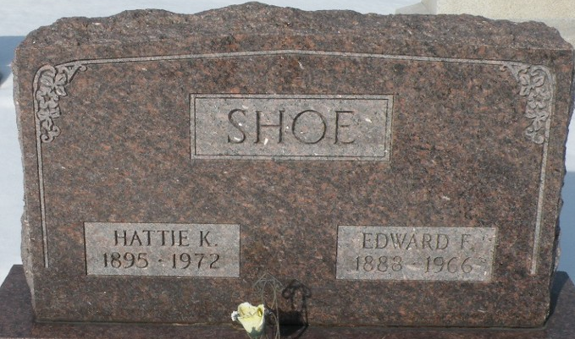
Photo by Tera

Mrs. Hattie Shoe, 77, 419 Grant St., Decatur, died Thursday morning in her home. She was the mother of Mrs. Howard (Pauline) Holloway, Greentown.
Surviving in addition to Mrs. Holloway are another daughter, a son, a brother, a sister, 15 grandchildren and 36 great-grandchildren.
Funeral services will be at 1:30 p.m. Sunday in the Zwick Funeral Home, Decatur, with the Rev. Sylvester Martin officiating. Burial will be in the Decatur Cemetery. Friends may call at the funeral home after 7 p.m. Friday.

Kokomo Tribune, Howard County, Indiana
Friday, October 27, 1972

**
Mrs. Hattie Shoe Dies Unexpectedly

Mrs. Hattie Shoe, 77, widow of Edward F. Shoe, was found dead Thursday morning at her home, 419 Grand Street. Death, due to natural causes, was unexpected.
She was born in Wells county May 23, 1895, a daughter of Bruce and Ellen Clark-Niblick, and was married to Edward F. Shoe Sept. 9, 1911. Her husband preceded her in death Dec. 22, 1966. Mrs. Shoe was a member of the Nuttman Ave United Brethren Church.
Surviving are two daughters, Mrs. Howard (Pauline) Holloway of Greentown, and Mrs. Arley (Marcile) Baty of Clinton, Ia.; one son, Edward L. (Bud) Shoe of Fort Wayne; one sister, Mrs. Jim (Velma) Garner of Decatur route 5; one brother, Charles Niblick of Fort Wayne; 15 grandchildren and 36 great-grandchildren. A son, Lewis, died in 1946.
Funeral rites will be conducted at 1:30 p.m. Sunday at the Zwick funeral home, with Rev. Sylvester Martin officiating. Burial will be in the Decatur cemetery. Friends may call at the funeral home after 7 p.m. today until time of the services.

Decatur Daily Democrat, Adams County, Indiana
Friday, October 27, 1972

