Edward F. Shoe
January 6, 1888 – December 21, 1966

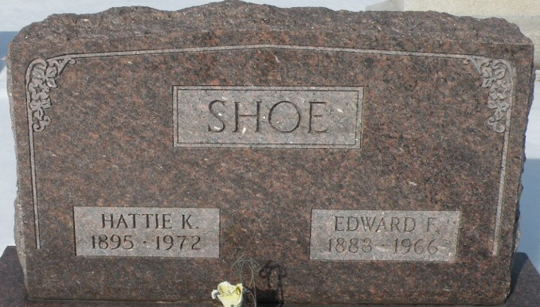
Photo by Tera

Edward F Shoe
in the Indiana, U.S., Death Certificates, 1899-2017
Name Edward F Shoe
Gender Male
Race Caucasian (White)
Marital Status Married
Age 78
Birth Date 6 Jan 1888
Birth Place Ohio
Death Date 21 Dec 1966
Death Place Decatur, Adams, Indiana, USA
Death Registration Date 1966
Father Mathew Shoe
Mother Jennie Anderson
Informant Mrs. Hattie Shoe; wife; Decatur, Indiana
Burial December 24, 1966; Decatur Cemetery; Decatur, Indiana

