William Shoaf
September 30, 1863 – March 26, 1943

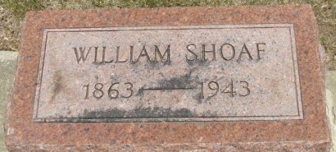
Photo by Alicia Kneuss

William Shoaf Dies Suddenly Last Night
Heart Attack Fatal to Kirkland Farmer
William Shoaf, 79, prominent Kirkland Township farmer, died suddenly of a heart attack at 10:15 o’clock Sunday night at his home, six miles southwest of Decatur. He had suffered a fall January 6 and was taken home from the Adams County Memorial Hospital Saturday afternoon, apparently in excellent health until the fatal seizure last night.
He was born in Hocking County, O., September 30, 1863, the son of John Gottlieb and Mary Hattrick Shoaf, but had lived in Adams County for more than 75 years. His wife, the former Sadie Marie Benedict, preceded him in death two years ago.
Surviving are the following children: Chester, Charles, ed, Mrs. Noah Egley, Mrs. Frank Laiger and Mrs. May Messer, all of near Decatur; Mrs. Ora Ratcliff of Ossian; Fred Shoaf of Allen County and Pvt. Frank Shoaf, with the U.S. Army in the South Pacific; one brother, Andrew Shoaf of Adams County; 23 grandchildren and 22 great-grandchildren. One daughter, one brother and one sister are deceased.
Funeral services will be held Wednesday afternoon at 1:30 o’clock at the home and at 2 pm at the St. Luke’s Evangelical and Reformed Church in Hendricks. Rev. H. R. Meckstroth officiating. Burial will be in the Decatur Cemetery. Grandsons will serve as pallbearers. The body will be removed from the Black Funeral Home this evening and may be viewed after 7:30 o’clock tonight.

Adams County Historical Museum, Adams County, Indiana
1943B March-December Scrapbook, image 33
Handwritten date: Monday, March 27, 1943

