Wayne Richard Shoaf
October 28, 1929 -

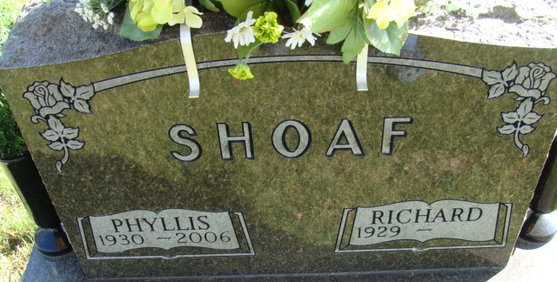
Photo by Alicia Kneuss

Mayne Richard Shoaf
in the Indiana, U.S., Birth Certificates, 1907-1944
Name Wayne Richard Shoaf
Gender Male
Birth Date Oct. 23, 1929
Birth Place Washington, Adams, Indiana, USA
Father Roy Shoaf; age 30
Mother Martha Hanni; age 29; 3rd child; all living
Certificate Number 44486
Roll number 40474_356567
Volume Range 96 - 90
**
Indiana, U.S., Marriage Certificates, 1960-2012
Name Wayne Shoaf
Gender Male
Race White
Marriage Age 21
Birth Date 28 Oct 1929
Birth Place Adams, Indiana
Marriage License Date 24 Feb 1951
Marriage Date 24 Feb 1951
Marriage Place Adams, Indiana, USA
Residence Place Decatur, Indiana
Father Roy Shoaf
Mother Martha Hanni
Spouse Phyllis Strickler
Officiator Samuel Emerick

