Terry Lee Shoaf
June 11, 1939 – October 8, 2006

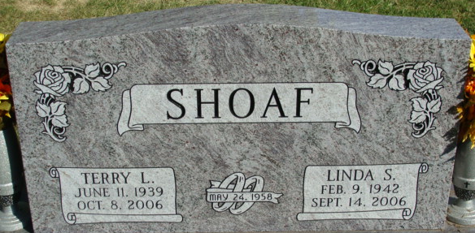
Photo by Alicia Kneuss

Terry Lee Shoaf, 67 years old of Decatur, Indiana, passed away on Sunday, October 8, 2006 in Adams Memorial Hospital located in Decatur.
He was born on Sunday, June 11, 1939 in Adams County, Indiana, the son of the late Raymond F. Shoaf and the late Dorothy (Elston) Shoaf. He married the late Linda Sue Shoaf on May 24, 1958. She passed away on September 14 of this year.
Terry served in the United States Army Reserves was retired from the Dana Corporation with 38 years of service.
Surviving are his son, Scott A. Shoaf of Decatur, Indiana, son, Brian A. Shoaf of Fort Wayne, Indiana, son, Stacy Shoaf of Fort Wayne, Indiana, son, Joshua Shoaf of Decatur, Indiana, son, Randy Shoaf of Decatur, Indiana, sister, Karen Joseph of Decatur, Indiana, sister, Mrs. Bud (Janet) Leininger of Monroeville, Indiana, sister, Mrs. Chuck (Pam) Bollenbacher of Rockford, Ohio, sister, Mrs. Jerry (Darlene) Alexander of Fort Wayne, Indiana, brother, Allen Shoaf of Decatur, Indiana, brother, Bill Shoaf of Decatur, Indiana, brother, Phil Shoaf of Willshire, Ohio, brother, Paul Shoaf of Fort Wayne, Indiana, and three grandchildren.
Preceding Terry in death were three sisters, Carol Murray, Barbara Tumbleson and Dorothy LaRae Dixon.
Funeral services will be held at 11:00 a.m. Thursday, October 12, 2006 in the Zwick & Jahn Funeral Home with Pastor Anthony Stidam officiating. Interment will follow in the Decatur Cemetery with graveside services provided by Adams Post #43 Color Guard. Friends will be received from 2:00 p.m.to 4:00 p.m. and 5:00 p.m. to 8:00 p.m., Wednesday, October 11 in the Zwick & Jahn Funeral Home, Decatur.
Preferred memorials are to Adams County Community Foundation Angel Fund or Bi-County Services.

Zwick & Jahn Funeral Home, Adams County, Indiana
October 9, 2006

