Stacey L. Shoaf
May 21, 1967 – December 29, 2019

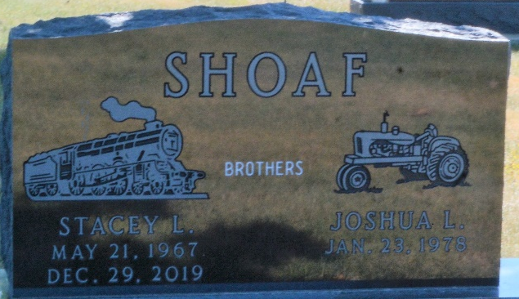
Photo by Deb Curry

Stacey L. Shoaf, 52, of Fort Wayne, Indiana passed away on Sunday, December 29, 2019, unexpectedly at his residence. He was born on May 21, 1967, in Decatur, Indiana to the late Terry Lee Shoaf and the late Linda Sue (Andrews) Shoaf.
Stacey loved trains and found joy taking rides on them. He also had a love for animals, especially elephants. Stacey liked swimming, socializing with the public, and enjoyed being outdoors when the weather was nice out. He also enjoyed swinging on the porch swing when being outside. He loved eating at McDonald’s and that is the place he liked to go to every Friday. He enjoyed being around friends and family whenever he got the chance. Again, food was something he enjoyed; he was not very picky when it came to eating. He liked to hold your hands at times and give out hugs. Even though many people would look at him and think he was not intelligent because he could not speak, he was very smart and would remember how to get to places or remember places he had been too. He easily would get tickled over some of the simplest things in life. Stacey loved Christmas especially Santa and Rudolph. He loved clowns and liked to laugh!
He survived by four brothers, Brian A. (Caryn) Shoaf of Noblesville, Indiana, Scott A. Shoaf of Decatur, Indiana, Joshua L. Shoaf of Bluffton, Indiana, and Randy Shoaf of Decatur, Indiana; aunt, Karen Joseph of Decatur, Indiana; uncle, Paul (Michelle) Shoaf of Fort Wayne, Indiana; two uncles, Allen (Jean) Shoaf of Decatur, Indiana and Philip (Carolyn) Shoaf of Willshire, Ohio; three aunts Janet Leniger of Fort Wayne, Indiana, Darlene (Jerry) Alexander of Berne, Indiana and Pamela (Chuck) Bollenbacher of Rockford, Ohio.
A memorial service will be held at 4 p.m. on Saturday, January 4, 2020, at the Zwick & Jahn Funeral Home in Decatur with Life Celebrant Dave McIntire presiding. Friends and family will be received from 3 p.m. until the time of service on Saturday.
Preferred memorials can be given to Special Olympics.

Zwick & Jahn Funeral Home, Adams County, Indiana
December 30, 2019

