Sandra Kay Shoaf
July 17, 1963 – January 15, 1980

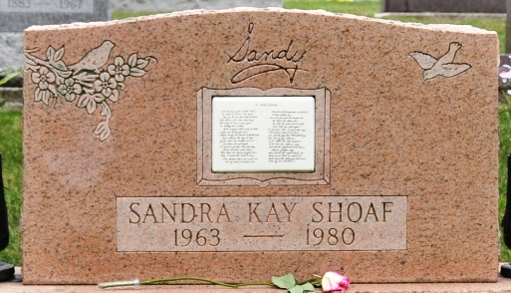
Photo by Deb Curry

Sandra Kay Shcaf
in the Indiana, U.S., Death Certificates, 1899-2017
Name Sandra Kay Shcaf
[Sandra Kay Shoaf]
Gender Female
Race White
Marital Status Never Married (Single)
Age 16
Birth Date 17 Jul 1963
Birth Place Indiana
Death Date 15 Jan 1980; vehicle accident
Death Place Decatur, Adams, Indiana, USA
Death Registration Date 1980
Father William Shoaf
Mother Carolyn Bassett
Informant Mrs. Carolyn Shoaf; Decatur, Indiana
Burial January 18, 1980; Decatur Cemetery; Decatur, Indiana

