Sadie Marie (Benedict) Shoaf
October 11, 1867 – November 28, 1940

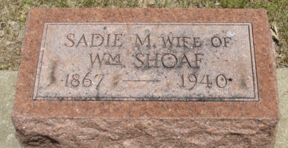
Photo of Alicia Kneuss

Left side of article cut off a bit
MRS. SHOAF IS TAKEN BY DEATH
Mrs. William Shoaf Dies Thursday Evening After Month's Illness
Sadie Marie Shoaf, 73, wife of William Shoaf, of Decatur route ?, died at 4 o'clock Thursday evening at the Adams County Memorial Hospital. Death followed a ? illness of complications.
She was born in Ohio, October 11, 1867, the daughter of Christ and Christena Boone-Benedict. She married William Shoaf in Decatur ? 12, 1888. She was a member of St. Luke's Evangelical and Reformed Church and of the ladies society of the church.
Surviving besides the husband are ? sons: Chester, Charley, Ed??, Frank and Fred, all in or near Decatur; four daughters: Mrs. ? Egley of Monroe, Mrs. Mable ?, Decatur route 2, Mrs. May ? of Decatur, and Mrs. Ireta ? of Ossian; one sister, Mrs. ? Martin of Decatur route 2; (cut off)
Decatur Daily Democrat; Adams County, Indiana
Friday, November 29, 1940
**
Indiana, U.S., Death Certificates, 1899-2011
Name: Sadie Marie Schoaf
[Sadie Marie Bendedict]
Gender: Female
Race: White
Age: 73
Marital status: Married
Birth Date: 11 Oct 1867
Birth Place: Ohio
Death Date: 28 Nov 1940
Death Place: Decatur, Adams, Indiana, USA
Father: Christ Bendedict
Mother: Christina Brunn
Spouse: Wm Schoaf
Informant: Mrs. Mable Linniger; Decatur, Indiana
Burial: December 1, 1940; Decatur Cemetery; Decatur, Indiana

