Roy O. Shoaf
November 30, 1898 – October 16, 1962

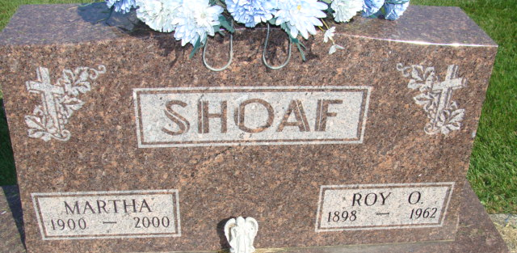
Photo by Alicia Kneuss

Roy O Shoaf
in the Indiana, U.S., Death Certificates, 1899-2017
Name Roy O Shoaf
Gender Male
Race White
Marital Status Married
Age 63
Birth Date 30 Nov 1898
Birth Place Indiana
Death Date 16 Oct 1962
Death Place Decatur, Adams, Indiana, USA
Death Registration Date 1962
Father Ambrose Shoaf
Mother Rosetta Snyder
Informant Mrs. Martha Shoaf; wife; Decatur, Indiana
Burial October 19, 1962; Decatur Cemetery; Decatur, Indiana

