Ronald E. Shoaf
1943 - 1943

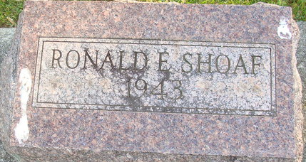
Photo by Alicia Kneuss

No further information found at this time

