Raymond F. Shoaf
April 1, 1913 – June 5, 1978

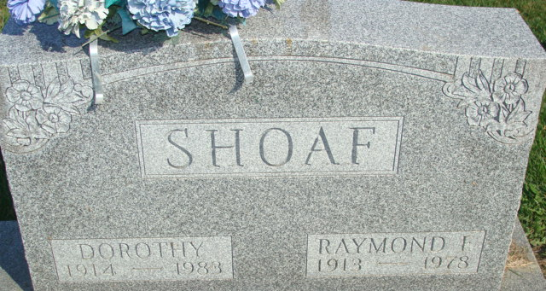
Photo by Alicia Kneuss

Raymond F Shoaf
in the Indiana, U.S., Death Certificates, 1899-2017
Name Raymond F Shoaf
Gender Male
Race White
Marital Status Married
Age 65
Birth Date 1 Apr 1913
Birth Place Indiana
Death Date 5 Jun 1978
Death Place Decatur, Adams, Indiana, USA
Death Registration Date 1978
Father Chester Shoaf
Mother Blanche Hoffman
Spouse Dorothy Elston
Informant Mrs. Dorothy Shoaf; Decatur, Indiana
Burial June 8, 1978; Decatur Cemetery; Decatur, Indiana

