Phyllis J. (Strickler) Shoaf
September 21, 1930 – July 17, 2006

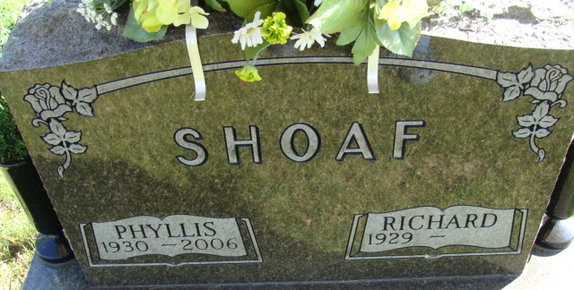
Photo by Alicia Kneuss

Phyllis J. Shoaf, 75, of Decatur, died Monday, July 17, 2006, at Adams Memorial Hospital. Born Sept. 21, 1930, in Decatur, she was the daughter of Kenneth L. Strickler and Bertha E. (Yager). She married W. Richard Shoaf on Feb. 24, 1951.
She attended Monroe United Brethren in Christ Church. She was a homemaker and also farmed with her husband.
Surviving is her husband, W. Richard Shoaf of Decatur; father, Kenneth L. Strickler of Decatur; two daughters, Mrs. Charles (Victoria L.) Lane and Keely A. Shoaf, both of Monroe; three brothers, Victor Strickler, Donald Strickler and Dan Strickler, all of Decatur; one sister, Barb Carroll of Lima, Ohio; and two grandchildren. She was preceded in death by her mother.
Private family service and visitation will be held. The Rev. Wes Kuntzman officiating. Burial in Decatur Cemetery.
Memorials to Monroe United Brethren Church, Adams County Home Health Care Agency or ACCF Angel Cancer Fund can be made through Haggard & Sefton Funeral Home.

News-Sentinel, Allen County, Indiana
Thursday, July 20, 2006

