Martha (Hannie) Shoaf
October 22, 1900 – February 18, 2000

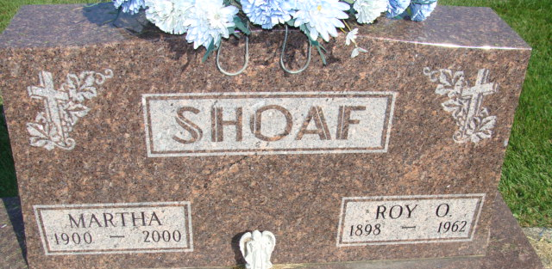
Photo by Alicia Kneuss

Martha Shoaf
in the Indiana, U.S., Death Certificates, 1899-2017

Name Martha Shoaf
[Martha Hannie]
Gender Female
Race White
Marital Status Widowed
Age 99
Birth Date 22 Oct 1900
Birth Place Adams County, Indiana
Death Date 18 Feb 2000
Death Place Decatur, Adams, Indiana, USA
Death Registration Date 2000
Father Gottlieb Hannie
Mother Lisetta Rufenacht
Informant Wayne R. Shoaf; son; Decatur, Indiana
Burial February 23, 2000; Decatur Cemetery; Decatur, Indiana

