Margery Kathryn (Myers) Shoaf
May 27, 1896 – March 30, 1947

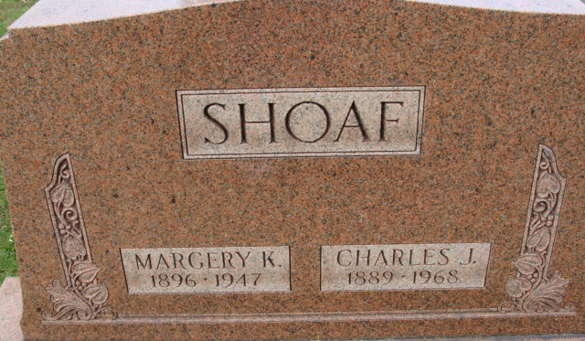
Photo by Alicia Kneuss

Margery Kathryn Sheaf
in the Indiana, U.S., Death Certificates, 1899-2017
Name Margery Kathryn Shoaf
[Margery Kathryn Myers]
Gender Female
Race White
Marital Status Married
Age 50
Birth Date 27 May 1896
Birth Place Indiana
Death Date 30 Mar 1947
Death Place Indianapolis, Marion, Indiana, USA
Death Registration Date 1947
Father Simon Myers
Mother Sarah Muery
Spouse Charles Shoaf
Informant Charles Shoaf; Decatur, Indiana
Burial April 2, 1947; Decatur, Indiana

