Lydia (Hannie) Shoaf
May 30, 1902 – January 9, 1999

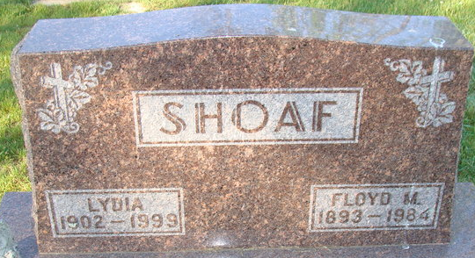
Photo by Alicia Kneuss

Lydia Shoaf
in the Indiana, U.S., Death Certificates, 1899-2017
Name Lydia Shoaf
[Lydia Hannie]
Gender Female
Race White
Marital Status Widowed
Age 96
Birth Date 30 May 1902
Birth Place Adams County, Indiana
Death Date 9 Jan 1999
Death Place Decatur, Adams, Indiana, USA
Death Registration Date 1999
Father Gottlieb Hannie
Mother Lisetta Rufenacht
Informant Mrs. Virginia Fosnaugh; daughter; Willshire, Ohio
Burial January 13, 1999; Decatur Cemetery; Decatur, Indiana

