Linda Sue (Andrews) Shoaf
February 9, 1942 – September 14, 2006

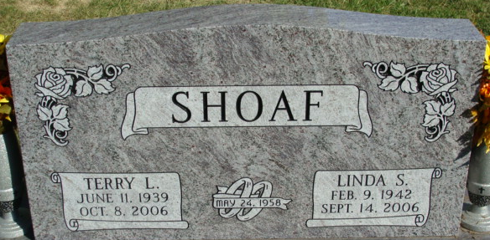
Photo by Alicia Kneuss

Linda Sue Shoaf, 64 years old of Decatur, Indiana, passed away on Thursday, September 14, 2006 in the Village of Heritage located in Monroeville, Indiana. She had been ill since May.
She was born on Monday, February 9, 1942 in Decatur, Indiana the daughter of the late Russell Andrews and the late Idora (Lough) Andrews. She married Terry Lee Shoaf in Decatur, Indiana and they celebrated their 48th wedding anniversary this year.
She was owner and operator of Yuppy Puppie Grooming in Decatur, Indiana.
Surviving are her husband, Terry Lee Shoaf of Decatur, Indiana, son, Scott A. Shoaf of Decatur, Indiana, son, Joshua Shoaf of Decatur, Indiana, son, Brian A. Shoaf of Fort Wayne, Indiana, son, Randy Shoaf of Decatur, Indiana, son, Stacy Shoaf of Fort Wayne, Indiana and three grandchildren.
Preceding Linda in death was one sister, Janie Gallemeyer.
Funeral services will be held at 10:30 a.m. Monday, September 18, 2006 in the Zwick & Jahn Funeral Home, Decatur, Indiana. Interment will follow in the Decatur Cemetery. Friends will be received from noon to 3:00 p.m. and 4:00 to 6:00 p.m., Sunday, September 17 in the Zwick & Jahn Funeral Home, Decatur.

Zwick & Jahn Funeral Home, Adams County, Indiana
September 15, 2006

