Joseph Shoaf
January 23, 1856 – August 21, 1925

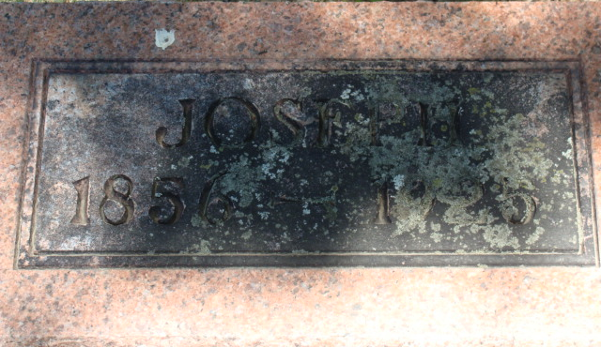
Photo by Alicia Kneuss

Joseph Shoaf from Fry/Baker Family Tree
Father Johann Gottlieb Shoaf
Mother Mary Ann Hutchison
Birth 23 Jan 1856 Hocking, Fairfield, Ohio, USA
Death 21 Aug 1925 Adams, Indiana, USA
Residence 1870 Adams, Indiana, US

