Helena (Sprague) Shoaf
1895 – January 2, 1946

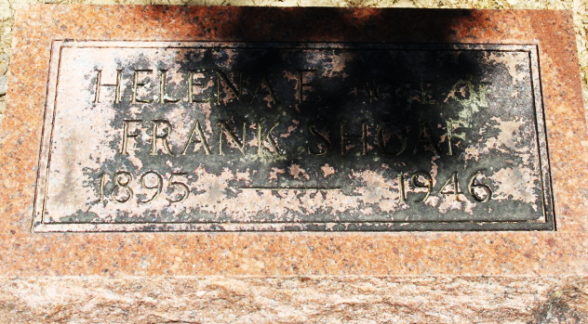
Photo by Alicia Kneuss

Helena SPRAGUE from tree Charles Joray
Death 2 Jan 1947 Indiana, USA
Spouse Franklin Sylvester SHOAF (1901-1960)
2577 People 0 Records 0 Sources
**
Ohio, U.S., Rutherford B. Hayes Presidential Center Obituary Index, 1810s-2016
Name Helena Shoaf
Death Age 51
Birth Date abt 1896
Death Date 1947
Death Place Ohio, USA
Newspaper Information Newspaper: Wilshire Herald, Newspaper Date: 09 Jan 1947, Newspaper Page: 3 Column: ; Repository: Brumback Public Library (Van Wert, Ohio); Years Available:

