Harriet E. (Vogelwede) Shoaf
February 20, 1922 – August 14, 1992

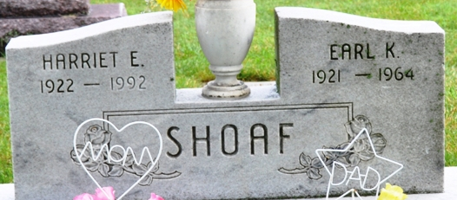
Photo by Alicia Kneuss

Harriet E Shoaf
in the Indiana, U.S., Death Certificates, 1899-2017
Name Harriet E Shoaf
[Harriet E Vogelwede]
Gender Female
Race White
Marital Status Widowed
Age 70
Birth Date 20 Feb 1922
Birth Place Indianapolis, Indiana
Death Date 14 Aug 1992
Death Place Decatur, Adams, Indiana, USA
Death Registration Date 1992
Father Bernard Vogelwede
Mother Edith Green
Informant Linda Grote; daughter; Decatur, Indiana
Burial August 18, 1992; Decatur Cemetery; Decatur, Indiana
**

Indiana, U.S., Marriage Certificates, 1960-2012
Name Harriet Gilson
Gender Female
Race White
Marriage Age 19
Birth Date 20 Feb 1922
Birth Place Marion
Marriage License Date 27 Dec 1941
Marriage Date 1 Jan 1942
Marriage Place Adams, Indiana, USA
Residence Place Decatur, Indiana
Spouse Earl K Shoaf

