Frank S. Shoaf
February 8, 1901 – July 9, 1960

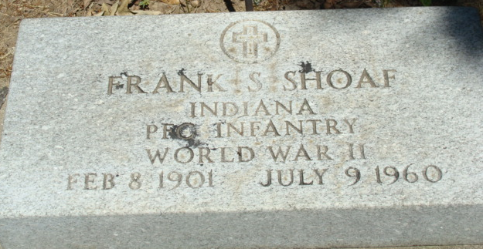
Photo by Alicia Kneuss

Frank Shoaf Dies Suddenly Saturday
Frank S. Shoaf, 59, native of Fort Wayne for the past 11 years, died suddenly at 12:30 o’clock Saturday afternoon of a coronary occlusion at the home of a sister, Mrs. Mable Liniger, west of Decatur.
He was born in Adams County Feb. 8, 1901, a son of William and Sadie Benedict-Shoaf and resided at the Kirkland Township farm home until entering the U.S. Army during World War II. He had been employed for a number of years as a machine operator at the Zollner Pistons plant in Fort Wayne. He had resided at 1121 Ohio Street, Fort Wayne, for the past 11 years.
His wife, the former Helena Sprague, preceded him in death. Mr. Shoaf was a member of the St. Luke’s E. and R. Church, Masonic Lodge, the American Legion, Veterans of Foreign Wars, and the B.P.O. Elks, all of Decatur.
Surviving are four sisters, Mrs. Liniger, Mrs. Noah Egley, Mrs. Mae Musser and Mrs. Ireta Ratliff, all of near Decatur, and four brothers, Chester, Edward and Charles Shoaf, all of near Decatur, and Fred Shoaf of Fort Wayne.
Funeral services will be conducted at 2 p.m. Tuesday at the Black Funeral Home, the Rev. L. C. Minsterman officiating. Burial will be in the Decatur Cemetery, with military rites by the American Legion. Friends may call at the funeral home until time of the services. Masonic services will be held at the funeral home tonight at 8 o’clock.

Adams County Historical Museum, Adams County, Indiana
January 1958 – December 1960 Scrapbook, image 47
Handwritten date: Monday, July 11, 1960

