Floyd M. Shoaf
July 7, 1893 – August 6, 1984

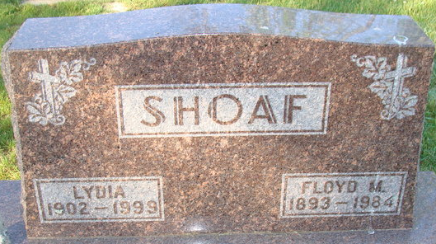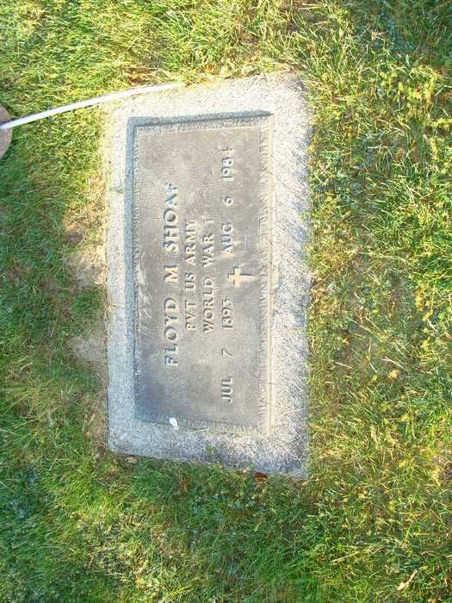
Photo by Barbara Baker Anderson

Floyd Mertin Shoaf
in the U.S., World War II Draft Registration Cards, 1942

Name Floyd Mertin Shoaf
Gender Male
Race White
Birth Date 7 Jul 1893
Birth Place Adams City, Indiana, USA
Residence Place Adams City, Indiana, USA
Military Draft Date 1942
Next of Kin Lydia Shoaf
**
Ohio, U.S., County Marriage Records, 1774-1993
Name Floyd M. Shoaf
Gender Male
Marriage Age 26
Birth Date abt 1893
Marriage Date 26 Aug 1919
Marriage Place Williams, Ohio, USA
Father Ambrose Shoaf
Mother Rosie Snyder
Spouse Lydia L. Hammie
Film Number 002130934

**
U.S., Department of Veterans Affairs BIRLS Death File, 1850-2010
Name Floyd Martin Shoaf
Gender Male
Death Date 6 Aug 1984
SSN xxx

