Edward L. Shoaf
January 12, 1892 – December 16, 1969

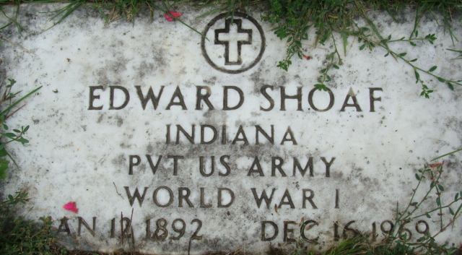
Photo by Alicia Kneuss

Edward Shoaf Dies of Heart Attack

Edward L. Shoaf, 77, well-known Adams County retired farmer, died suddenly of a heart attack at 11:30 a.m. Tuesday at his home on Decatur Route 4. A lifelong resident of Adams County, he was born to William and Sadie Benedict-Shoaf Jan. 12, 1892, and was married to Ethel Courtney July 18, 1941.
A veteran of World War I, Mr. Shoaf was a member of Adams Post 43, American Legion, and the Moose Lodge.
Surviving is his wife; two sons, Roger and Bernard Shoaf, both of Decatur; four sisters, Mrs. Noah (Lulu) Egly of Monroe Route 1, Mrs. Mabel Lininger of Decatur Route 4, Mrs. Mae Musser of Decatur Route 3, and Mrs. Ora (Ireta) Ratcliff of Decatur Route 6; one brother, Fred Shoaf of Waynedale; and seven grandchildren. Three brothers and one sister are deceased.
Funeral services will be conducted at 10:301 a.m. Friday at the Winteregg-Linn Funeral Home, with Rev. Sylvester martin officiating. Burial will be in the Decatur Cemetery, with military rites by the American Legion. Friends may call at the funeral home after 7 p.m. today until time of the services. The Moose Lodge will hold services at 7 p.m. Thursday.

Decatur Daily Democrat, Adams County, Indiana
Wednesday, December 17, 1969

