Earl K. Shoaf
March 1, 1921 – March 21, 1964

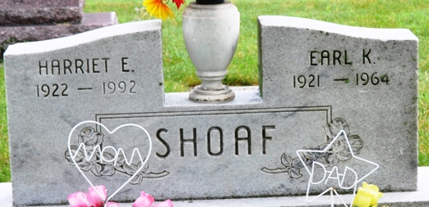
Photo by Deb Curry

Earl K Shoaf
in the Indiana, U.S., Death Certificates, 1899-2017
Name Earl K Shoaf
Gender Male
Race White
Marital Status Married
Age 43
Birth Date 1 Mar 1921
Birth Place Indiana
Death Date 21 Mar 1964
Death Place Decatur, Adams, Indiana, USA
Death Registration Date 1964
Father Roy Shoaf
Mother Martha Hannie
Spouse Harriet Gilson
Informant Mrs. Harriet Shoaf; wife; Monroeville, Indiana
Burial March 25, 1964; Decatur Cemetery; Decatur, Indiana

