Dorothy (Elston) Shoaf
March 24, 1914 – October 2, 1983

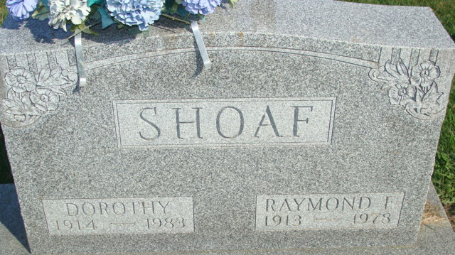
Photo by PLS

Dorothy Shoaf
in the Indiana, U.S., Death Certificates, 1899-2017
Name Dorothy Shoaf
[Dorothy Elston]
Gender Female
Race White
Marital Status Widowed
Age 69
Birth Date 24 Mar 1914
Birth Place Indiana
Death Date 2 Oct 1983
Death Place Decatur, Adams, Indiana, USA
Death Registration Date 1983
Father Elroy Elston
Mother Etta Morton
Informant Phillip Shoaf; son; Willshire, Ohio
Burial October 5, 1983; Decatur Cemetery; Decatur, Indiana

