Charles J. Shoaf
July 7, 1889 – September 26, 1968

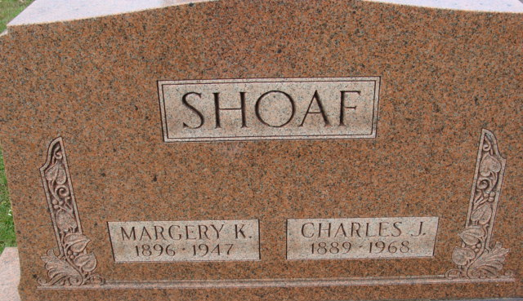
Photo by PLS

Charles J Shoaf
in the Indiana, U.S., Death Certificates, 1899-2017
Name Charles J Shoaf
Gender Male
Race White
Marital Status Married
Age 79
Birth Date abt 1889
Birth Place Indiana
Death Date 26 Sep 1968
Death Place Decatur, Adams, Indiana, USA
Death Registration Date 1968
Father William Shoaf
Mother Sadie Benedict
Spouse Olive Habegger Reynolds
Informant Mrs. Charles (Olive) Shoaf; wife; Decatur, Indiana
Burial September 30, 1968; Decatur Cemetery; Decatur, Indiana
**
Indiana, U.S., Marriage Certificates, 1960-2012
Name Charles Shoaf
Gender Male
Race White
Marriage Age 60
Birth Date 7 Jul 1889
Birth Place Adams, Indiana
Marriage License Date 3 Jan 1950
Marriage Date 3 Jan 1950
Marriage Place Adams, Indiana, USA
Residence Place Decatur, Indiana
Father William Shoaf
Mother Sadie Benedict
Spouse Olive Hebegger
Officiator J Pritchard Amstutz

