Robert Lawton Shirk
April 19, 1856 – December 6, 1923

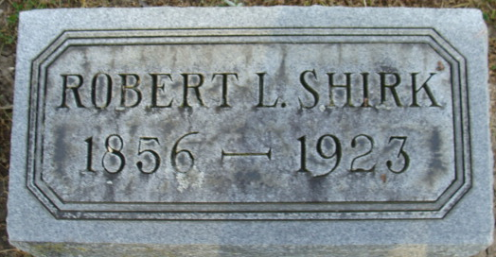
Photo by Alicia Kneuss

Robert L Shirk
in the Indiana, U.S., Death Certificates, 1899-2017
Name Robert L Shirk
Gender Male
Race White
Marital Status Married
Age 67
Birth Date 19 Apr 1856
Birth Place Franklin Co. PA.
Death Date 6 Dec 1923
Death Place Monroe, Adams, Indiana, USA
Death Registration Date 1923
Father Abraham Shirk
Mother Elizabeth
Spouse Luella
Informant Ben F. Shirk; Fort Wayne, Indiana
Burial December 8, 1923; Decatur Cemetery
**
Robert Lawton Shirk from Kurtz Family Tree
Spouse Luella Virginia 'Ella' Bouse
Father Abraham 'Abram' (Garver) Shirk
Mother Elizabeth Ellen Lawton
Children Robert Eugene
Birth 19 Apr 1856 Franklin, Pennsylvania, USA
Death 6 Dec 1923 Adams, Indiana, USA
Residence 1860 Greene, Franklin, Pennsylvania, USA

