Luella (Bouse) Shirk
October 4, 1867 – October 31, 1926

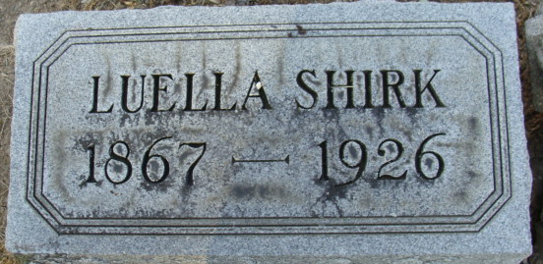
Photo by Alicia Kneuss

Luella Shirk
in the Indiana, U.S., Death Certificates, 1899-2017
Name Luella Shirk
[Luella Bouse]
Gender Female
Race White
Marital Status Widowed
Age 59
Birth Date 4 Oct 1867
Birth Place Indiana
Death Date 31 Oct 1926
Death Place Manrae, Adams, Indiana, USA
Death Registration Date 1926-1927
Father Asbury Bouse
Mother Margret Hall
Informant Ben F. Shirk; Fort Wayne, Indiana
Burial November 2, 1926; Decatur Cemetery

