Blanche Jane (Laisure) Shirk
June 14, 1889 – January 28, 1966

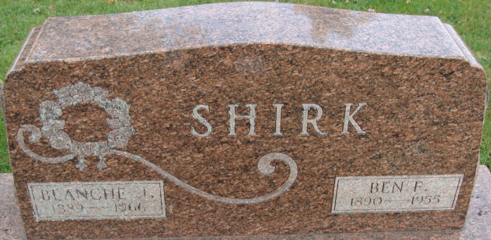
Photo by Alicia Kneuss

Services for Mrs. Ben F. Shirk, 2301 Florida Drive, Apt 2B, will be at 1 pm Sunday in D. O. McComb & Sons Funeral Home, Gordon Brown officiating. Burial will be in the Decatur Cemetery. Mrs. Shirk died at 11 am yesterday in Parkview Memorial Hospital where she had been a patient four days.
She was a native of Adams County and had resided in Fort Wayne since 1922. She was a member of the First Church of Christ Scientist.
Surviving is a daughter, Mrs. Ralph W. Bogardus, Fort Wayne; two sisters, Mrs. Martha Davis, Dayton, Ohio, and Mrs. Hattie Longenberger, Monroe; and one grandchild.
Friends may call at the funeral home from 2 to 4 and 7 to 9 pm today.
Journal-Gazette, Allen County, Indiana
January 29, 1966

**
Indiana, Death Certificates, 1899-2017
Name Blanche Jane Shirk
[Blanche Jane Laisure]
Gender Female
Race White
Age 76
Marital Status Widowed
Birth Date 14 Jun 1889
Birth Place Indiana
Death Date 28 Jan 1966
Death Place Fort Wayne, Allen, Indiana, USA
Death Registration Date 1966
Father David W Laisure
Mother Laura Pogue
Informant Ralph Bogardus, son-in-law
Burial Decatur Cemetery 1-30-1966

