Ben F. Shirk
March 3, 1890 – December 29, 1955

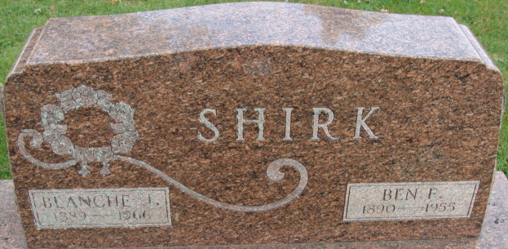
Photo by Alicia Kneuss

Indiana, Death Certificates, 1899-2017

Name Ben F Shirk
Gender Male
Race White
Age 65
Marital Status Married
Birth Date 3 Mar 1890
Birth Place Tipton Co, Indiana
Death Date 29 Dec 1955
Death Place Fort Wayne, Allen, Indiana, USA
Death Registration Date 1955
Father Robert L Shirk
Mother Luella Bouse
Informant Blanche Shirk
Burial Maplewood Cemetery, 12-31-1955

