Margaret (Troutner) Shilling
December 5, 1848 – April 14, 1928

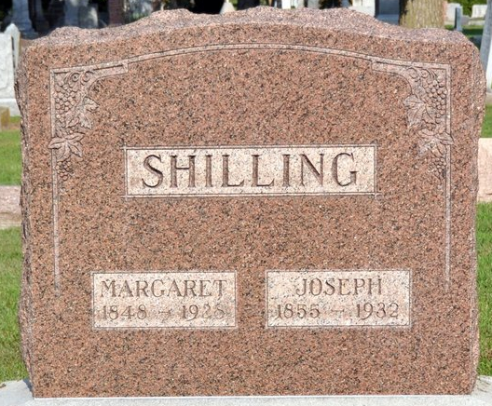
Photo by Deb Curry

OBITUARY
Mrs. Margaret Shilling, daughter of George and Mary Troutner, was born December 6, 1848 near Willshire, Ohio. On the morning of April 14, 1928, she took her departure to be with her Lord, whom she loved and served. The years of her pilgrimage exceeded the promised "three-score and ten" she having attained the advanced age of 79 years 4 months and 9 days.
While in youth she heard the voice of God calling for the service of her life, and at 18 years of age responded to the call, was happily converted, joined the M. E. Church at Willshire and remained faithful to her Savior and God to the end.
November 22, 1880 she was united in holy wedlock to Joseph Shilling, in whom she found a true, faithful and constant companion for over 47 years. Beginning their married life near Rockford, Ohio, later they lived near Willshire. After some years they moved to Adams County, Indiana living in the vicinity of Decatur. A number of years were spent near the St. Paul's Christian Union Church, where they became members and among the people of which church they formed many precious friendships and had many blessed experiences.
In 1913, Mr. Shilling purchased a farm east of Decatur, on the state line, where Mrs. Shilling with her companion began attending the Calvary Evangelical Church nearby, and shortly thereafter joined the church remaining faithful members until translated to the Church Triumphant. Their home was blessed with two children, one son Lewis Shilling, of the home farm; and one daughter, Mary G. Zerkel, living near Decatur.
Mother Shilling was a woman of the so-called "old school". She was hardy, frank, fearless, courageous, rightfully ambitious, honest, kind, and always ready to help. She had staunch convictions and always the courage of her convictions. She had splendid intellectual gifts. She was a true wife and mother, and faithfully in her own home. She was a kind neighbor and always ready to share with her neighbors and friends and God's servants, life's temporal blessings. Her home was always the welcomed retreat of the weary or needy servant of God; and he knew it mattered not whether his sojourn were only for a meal or a week there would be the same hearty welcome.
Mrs. Shilling was a positive staunch Christian. She had rare gifts in prayer conversation, extortion, and she was a great student of the word, and understood its spiritual message. The family alter was maintained in this home to the end.
It was Mother Shilling's desire that since she was not so well of recent months, she might go home before her beloved companion, and that she might not continue with a long lingering sickness. How wonderfully God granted her desire. Together they were permitted to live alone up to a week ago when she was stricken with a fatal illness.

Willshire Herald, Van Wert County, Ohio
April 15, 1928

**
The funeral of Mrs. Joseph Shilling, who died Saturday at her home in Harrison Township, was held this afternoon at her late home.
Mrs. Shilling was aged 79 years and spent her entire life in this country.
She is survived by her husband, a son, Louis S. Shilling, of Harrison township, and a daughter, Mrs. Mary Zerkle, of Adams County, Indiana. Interment was made in the cemetery at Decatur.

Twice Weekly, Van Wert County, Ohio
April 17, 1928

