Joseph Shilling
March 5, 1855 – March 9, 1932

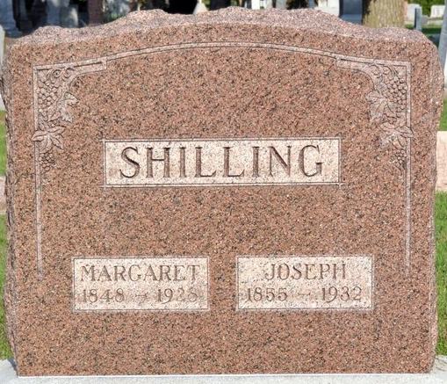
Photo by Deb Curry

Joseph Shilling, residing on the Ohio-Indiana state line, east of Decatur, died Wednesday afternoon, March 9. Deceased was a brother-in-law of the late Amos and Nathan Troutner and an uncle to W. L. Troutner.
Buchanan & Son, local undertakers, were summoned to prepare the body for burial.

Willshire Herald, Van Wert County, Ohio
Thursday, March 10, 1932

**
SHILLING FUNERAL FRIDAY
The funeral of Joseph Shilling, whose death was noted in these columns last week, was held at 1:30 o'clock last Friday afternoon from Calvary Evangelical church, conducted by Rev. M. W. Sunderman of Decatur, Indiana, assisted by Rev. F. L. Prestige, pastor of the Wren, Ohio, Baptist church.
Mr. Shilling died at his home six miles east of Decatur on the Indiana Ohio state line at 5:25 o'clock Wednesday evening, of complications. Mr. Shilling had been ill since last Christmas and was bedfast for several weeks.
The deceased lived on a farm in Adams County until 1912 when he moved to the present farm on the state line. He was a member of the Antioch Church. He had been a member of the Calvary Evangelical Church, near Decatur, for the past 21 years.
Mr. Shilling was born in Marion County, Ohio, March 5, 1855, the son of John and Catherine Shilling both deceased. He was united in marriage to Margaret Troutner of Van Wert on November 22, 1880. She preceded him in death on April 14, 1928.
Surviving are two children, Mrs. Hubert Zerkel of Decatur, and Louis S. Shilling, who lives on the home farm; five grandchildren; a brother, William Shilling of Oliver, Ohio; four sisters, Mrs. Lana Lindeman of Canton, Ohio; Mrs. Frances Hahner, Strasburg, Ohio; Mrs. Mary Kaiser, Kenton, Ohio; Mrs. Elizabeth Mitchell, Altamont, Ill.

Willshire Herald, Van Wert County, Ohio
Thursday, March 17, 1932

**
Ohio Deaths 1908-1953
Name : Joseph Shilling
Death date : 09 Mar 1932; Death place : Harrison, Van Wert, Ohio Birth date : 05 Mar 1855; Birth place : Ohio
Age at death : 77 years 4 days; Gender : Male
Marital status : Widowed; Race or color : Caucasian
Occupation : Farmer
Burial date : 11 Mar 1932; Cemetery name : Decatur, Ind. Cem.
Spouse name : Margaret Shilling
Father name : John Shilling b. Germany
Mother name : Catherine Stake b. Germany
GSU film number : 1992571; Digital GS number : 4001569
Image number : 1646; Certificate number : fn 20495

