Mary M. (Burger) Shifferly
January 24, 1922 – April 20, 2005

r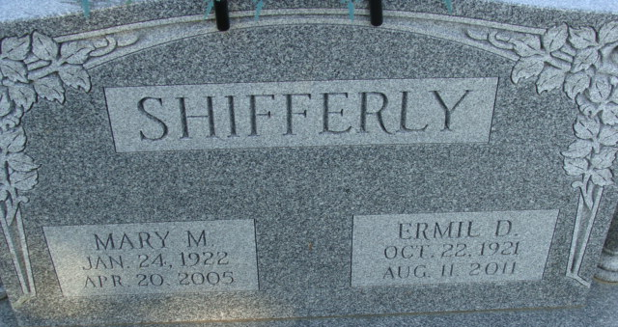
Photo by Alicia Kneuss

Mother of Mrs. Allen (Arlene K.) Steffen of Bluffton, Mary M. Shifferly, 83, died at 12:57 a.m. Wednesday, April 20 at Chalet Village in Berne. She had been a patient there since January. Born Jan. 24, 1922 in Adams County to Alva K. and Bertha Ann Welty Burger, she married Ermil D. Shifferly April 3, 1943 in St. Mary's Twp., Adams County. He survives.
A member of the Decatur Church of God, she retired from CTS in Berne after 18 1/2 years of service.
Additional survivors include a son, Duane D. Shifferly of rural Monroe; a brother, Robert M. Burger, Decatur; three sisters, Mrs. Gorman (Rosa) Fox, and Annie Fleming, both of Decatur, and Mrs. Harold (Lucrecia) Minnich, Willshire, Ohio; four grandchildren and 11 great-grandchildren.
Services at 10:30 a.m. Saturday will be at the Decatur Church of God, under the direction of Rev. Sandy Hildrebrand. Burial will follow at Decatur Cemetery. Calling hours are 2 to 4 p.m. and 5 to 8 p.m. Friday at Zwick & Jahn Funeral Home, Decatur, and one hour prior to services at the church on Saturday.
Memorials may be made to the Decatur Church of God.

Bluffton News-Banner, Wells County, Indiana
Thursday, April 21, 2005

