Lydia E. (Fuhrman) Shifferly
March 13, 1856 – February 29, 1924

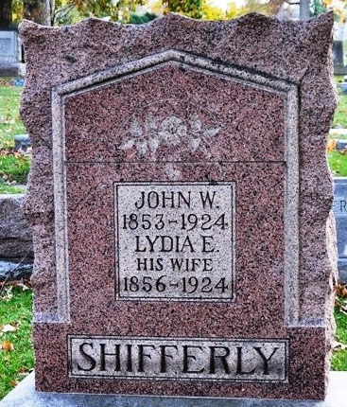
Photo by Deb Curry

Lydia E Shippert
in the Indiana, U.S., Death Certificates, 1899-2017
Name Lydia E Shifferly
[Lydia E Fuhrman]
Gender Female
Race White
Marital Status Married
Age 67
Birth Date 13 Mar 1856
Birth Place Indiana
Death Date 29 Feb 1924
Death Place Adams, Indiana, USA
Death Registration Date 1924
Father Henry Fuhrman
Mother Mary Beck
Spouse John W. Shifferly
Informant Otis E. Shifferly; Decatur, Indiana
Burial March 2, 1924; Decatur Cemetery

