John W. Shifferly
February 14, 1853 – October 22, 1924

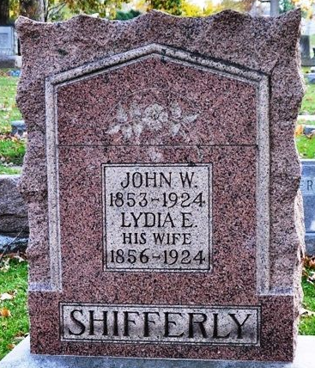
Photo by Deb Curry

John W Shifferly
in the Indiana, U.S., Death Certificates, 1899-2017
Name John W Shifferly
Gender Male
Race White
Marital Status Widowed
Age 72
Birth Date 14 Feb 1852
Birth Place Ohio
Death Date 22 Oct 1924
Death Place Wayne, Wayne, Indiana, USA
Death Registration Date 1924
Father John Shifferly
Mother Schwartz
Informant ??; Richmond, Indiana
Burial October 24, 1924; Maple Wood Cemetery

