Iona M. (Hart) Shifferly
May 19, 1885 – November 6, 1982

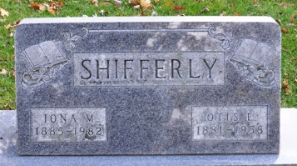
Photo by Deb Curry

Iona M. Shifferly
in the Indiana, U.S., Death Certificates, 1899-2017
Name Iona M. Shifferly
[Iona M. Hart]
Gender Female
Race White
Marital Status Widowed
Age 97
Birth Date 19 May 1885
Birth Place Indiana
Death Date 6 Nov 1982
Death Place Berne, Adams, Indiana, USA
Death Registration Date 1982
Father William Hart
Mother Elzetta Miller
Informant Mrs. Doris McDermott; Decatur, Indiana
Burial November 8, 1982; Decatur Cemetery

